Business Hub

Supervised By: Dr. Mahmoud Maqableh

Prepared By:

Ahmad Ziyad Al-Qudah (2212417)

Abdallah Omar Al-Qudah (0213338)

Leen Fadi Ghanem (0214447)

Submitted Date: 20/4/2025

# A diagram of a business structure AI-generated content may be incorrect.1. Use Case

# Flowcharts

## Student/Admin Login F.C

## 2.2 Student Register

## 2.3 Book Exchange F.C

## 2.4 Monitor Book Exchange F.C

## 2.5 Manage Academic Staff F.C

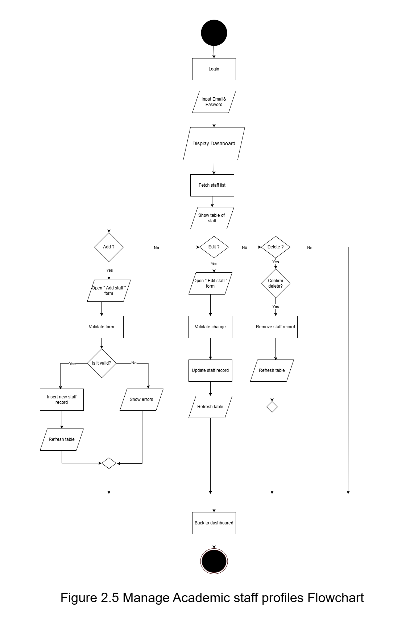2.5 Manage Academic Staff F.C

## 2.6 Manage Department F.C

# 3. Data Flow Diagram

## Context-Level Diagram

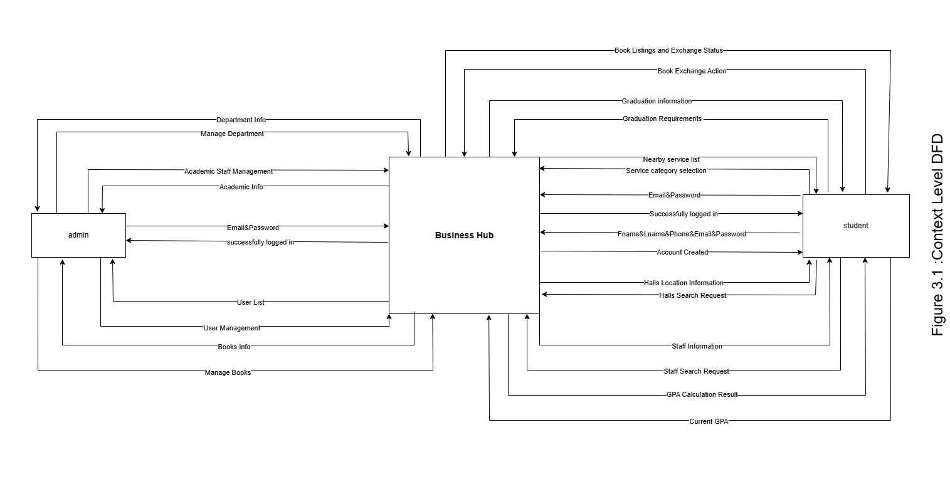

## 3.2 Zero-Level

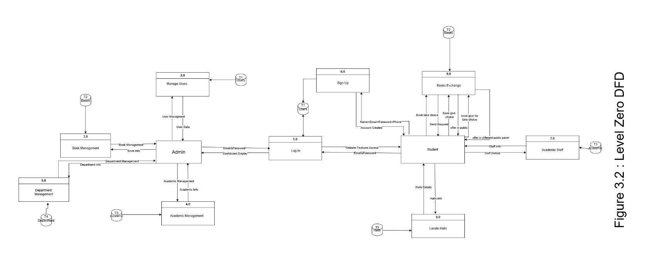

## 3.3 Child-Level

## 3.2 Zero-Level F.C

## Zero-Level Diagram

## Child-Level Diagram

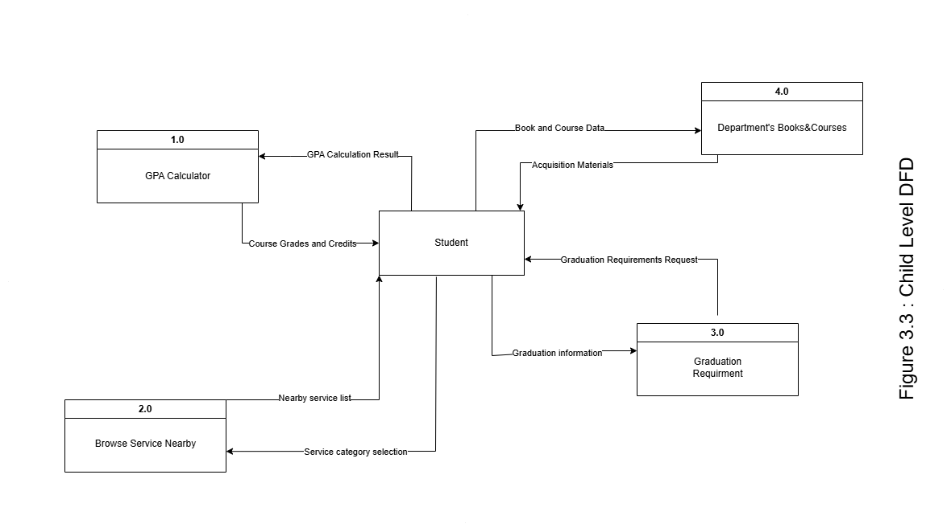

# 4. ER-Diagram

**Business Hub – Entity Relationship Diagram (ERD) Explanation**

This ER diagram represents the database structure for the Business Hub platform, designed to support book exchanges, academic resources, and student-staff interactions in a university setting.

users: Stores all registered users (students or super admins). Each user has personal info like name, email, phone, and a role (user or super_admin) that controls their permissions.

**Departments:** Represents academic departments (e.g., MIS, Finance). It links to most academic content across the site.

**Book_exchange:** Lists all available books for exchange, categorized by department.

**Book_offers:** When a user clicks “Give” on a book, an offer is created and stored here. It includes optional details (e.g., book condition), and may include a desired_book_id if the user is using the "Give for Take" feature.

**Book_requests:** If another user clicks “Take,” a request is recorded here. It links to the original offer and tracks its status (pending, accepted, or rejected).

**Notifications**: Generated when a book request is made. This alerts the user who posted the offer and helps facilitate communication.

**Chat_messages:** Stores real-time messages exchanged between users once a book request has been accepted. This enables them to coordinate the physical exchange.

**Courses:** Contains downloadable/viewable course resources for each department (e.g., links, descriptions).

**Books:** Represents static learning materials uploaded for each department, available through department pages (not part of the exchange system).

**Academic_staff:** A directory of academic staff members, including their office location, university email, and LinkedIn profile. Each is assigned to a department.

**Key Relationships**

A user can Offer books

Request offered books

Receive/send notifications

Chat with other users

A department:

Provides courses, staff, books, and exchange book listings

Each book offer:

Is tied to a user

Refers to a book from book_exchange

May specify a desired book (desired_book_id) for exchange

Each book request:

Is tied to a specific offer and user

Triggers a notification

If accepted, opens a chat session

# 5. Data Dictionary

## 5.1 Users Table

|  |  |  |
| --- | --- | --- |
| **Column** | **Type** | **Description** |
| **id** | INT AUTO_INCREMENT **PK** | Unique user identifier |
| first name | VARCHAR(100) | User’s given name |
| last name | VARCHAR(100) | User’s family name |
| email | VARCHAR(255) **UNIQUE** | Login email (must be unique) |
| phone | VARCHAR(20) | 10‑digit phone number |
| password | VARCHAR(255) | Hashed password |
| role | ENUM('user','super_admin') | Account type / permission level |
| created at | TIMESTAMP DEFAULT CURRENT_TIMESTAMP | Account creation timestamp |

## 5.2 Departments Table

|  |  |  |
| --- | --- | --- |
| Column | Type | Description |
| id | INT AUTO_INCREMENT **PK** | Unique department identifier |
| name | VARCHAR(100) | Department name (e.g. “MIS”, “Finance”) |

## 5.3 Book exchange Table

|  |  |  |
| --- | --- | --- |
| Column | Type | Description |
| id | INT AUTO_INCREMENT **PK** | Unique book listing identifier |
| book name | VARCHAR(255) | Title of the book |
| department_id | INT **FK** → departments.id | Which department this book belongs to |

## 5.4 Book offers Table

|  |  |  |
| --- | --- | --- |
| Column | Type | Description |
| id | INT AUTO_INCREMENT **PK** | Unique offer identifier |
| book_id | INT **FK** → book_exchange.id | The book being offered |
| user_id | INT **FK** → users.id | Who is offering the book |
| desired_book_id | INT **FK** → book_exchange.id | (Optional) Book they want in exchange (“Give‑for‑Take”) |
| details | TEXT | Notes on book condition, extras, etc. |
| timestamp | DATETIME DEFAULT CURRENT_TIMESTAMP | When the offer was created |

## 5.5 Book Requests Table

|  |  |  |
| --- | --- | --- |
| Column | Type | Description |
| id | INT AUTO_INCREMENT **PK** | Unique request identifier |
| offer_id | INT **FK** → book_offers.id | Which offer is being requested |
| requester_id | INT **FK** → users.id | Who is requesting the book |
| status | ENUM('pending','accepted','rejected') | Current request state |
| timestamp | DATETIME DEFAULT CURRENT_TIMESTAMP | When the request was made |

## 5.6 Notification Table

|  |  |  |
| --- | --- | --- |
| Column | Type | Description |
| id | INT AUTO_INCREMENT **PK** | Unique notification identifier |
| user_id | INT **FK** → users.id (sender) | Who triggered the notification (e.g. requester) |
| receiver_id | INT **FK** → users.id | Who should receive the notification |
| action_id | INT **FK** → book_requests.id | What action this notification is about (link to request) |
| type | VARCHAR(100) | Notification category (e.g. “book_request”) |
| message | TEXT | Human‑readable notification text |
| is_read | BOOLEAN DEFAULT FALSE | Whether the notification has been seen by the receiver |
| created_at | TIMESTAMP DEFAULT CURRENT_TIMESTAMP | When the notification was created |

## 5.7 Chat Messages Table

|  |  |  |
| --- | --- | --- |
| Column | Type | Description |
| id | INT AUTO_INCREMENT **PK** | Unique message identifier |
| sender_id | INT **FK** → users.id | Who sent the message |
| receiver_id | INT **FK** → users.id | Who receives the message |
| message | TEXT | The chat message content |
| timestamp | DATETIME DEFAULT CURRENT_TIMESTAMP | When the message was sent |

## 5.8 Courses Table

|  |  |  |
| --- | --- | --- |
| Column | Type | Description |
| id | INT AUTO_INCREMENT **PK** | Unique course identifier |
| department_id | INT **FK** → departments.id | Which department offers this course |
| course_name | VARCHAR(255) | Course title |
| course_link | TEXT | URL or path to download/view course materials |
| course_description | TEXT | Summary or syllabus description |

## 5.9 Books Table (Static Materials) Table

|  |  |  |
| --- | --- | --- |
| Column | Type | Description |
| id | INT AUTO_INCREMENT **PK** | Unique static‑book identifier |
| department_id | INT **FK** → departments.id | Which department this resource belongs to |
| book_name | VARCHAR(255) | Title of the static learning material |
| book_material | TEXT | URL or path to the file |

## 5.10 Academic Staff Table

|  |  |  |
| --- | --- | --- |
| Column | Type | Description |
| id | INT AUTO_INCREMENT **PK** | Unique staff member identifier |
| name | VARCHAR(255) | Full name |
| email | VARCHAR(255) | University email |
| linkedin | VARCHAR(255) | Link to LinkedIn profile (optional) |
| image | TEXT | Path or URL to profile picture |
| office_location | VARCHAR(255) | Office room or building (e.g., “Main 4th Floor”) |
| department_id | INT **FK** → departments.id | Department the staff belongs to |

# 6. Entity-Event Matrix

|  |  |  |
| --- | --- | --- |
| Entity / Events | Admin | Student |
| Register Account |  | C |
| Log in |  | C |
| Offer Book | R | C,D |
| Request Book | R | C,R |
| Give For Take | R | C,R |
| Browse Public Services |  | R |
| Monitor Book Exchanges | R |  |
| Manage Academic Staff | C,R,U,D |  |
| Manage Department | C,R,U,D |  |
| Manage Users | C,R,U,D |  |

# Mock Screens

